16th July 2020

Year 11 leavers’ events

Dear Year 11 students and families,

It is with regret that I am writing to inform you that we have had to make the decision to cancel our two planned Year 11 leavers’ events; the prom and the celebration event.

The DfE have released updated guidance to all schools as a result of increasing rates of infection nationally.

Following the Government announcement and consultation with Leeford Place, we are unable to re-book before the Summer holidays. We have discussed alternatives such as September or around Christmas, but this is very much a decision for the students.

Please use this link to express your opinion on the future of the prom Microsoft Forms.

We will have to cancel the leavers’ celebration event on Friday 25th June. This is due to increasing concerns about the Delta variant and students no longer being in school in bubbles.

We hope to organise some form of award ceremony in September but we are unsure at this stage what this will look like, or whether it will be for all students.

Once we have your responses regarding the prom, we will be in contact again.

If you have any questions, please contact Mrs. Starkey via the school office – office@ryecollege.co.uk.

Thank you for your understanding in this matter.

Yours sincerely,

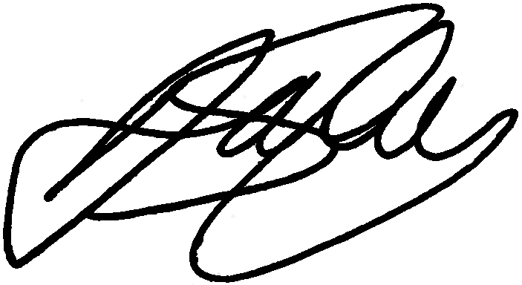

Mrs. D. Starkey
KS4 Learning Director

